**ART AUTHENTICATION USING DEEP NEURAL NETWORK**

*Submitted by*

**DEVI K.R**

**(****Univ. Reg No. 13408036)**

**SAMUEL PUNNOOSE JOHN**

**(Univ. Reg No. 13408090)**

**SHAREN AUGUSTINE**

**(Univ. Reg No. 13408095)**

Eighth Semester Computer Science and Engineering

*of*

MAR BASELIOS COLLEGE OF ENGINEERING AND TECHNOLOGY NALANCHIRA, THIRUVANANTHAPURAM– 695 015



**A Project Design Report**

**Submitted**

**To**

**THE FACULTY OF COMPUTER SCIENCE & ENGINEERING**

***In partial fulfillment of the requirements for the award of the degree***

***of***

**BACHELOR OF TECHNOLOGY**

**in**

**COMPUTER SCIENCE & ENGINEERING**

***Under University of Kerala***

**December 2016**

**Project Title: Art Authentication using Deep Neural Network**

**Department: Computer Science and Engineering**

**Name of the Guide: Mr. Sandeep S. R**

**Group Members: 1. Devi K. R**

**2. Samuel Punnoose John**

**3. Sharen Augustine**

**Mar Baselios College of Engineering & Technology**

**Mar Ivanious Vidyanagar, Nalanchira,**

**Thiruvananthapuram - 695 015**

**(Affiliated to University Of Kerala)**

**Department of Computer Science and Engineering**



**CERTIFICATE**

This is to certify that the Project Report titled “Art Authenication using Deep Neural Network” is a bonafide record of project presented by Devi K. R (Univ. Reg No. 13408036), Samuel Punnoose John (Univ. Reg No. 13408090) and Sharen Augustine (Univ. Reg No. 13408095).

Project Coordinator Project Guide Head of the Department

***Place: Thiruvananthapuram***

***Date: 18/01 /2017***

##### 

##### ACKNOWLEDGEMENT

First and foremost, we wish to thank **Fr. Wilson Thattaruthundil**,Bursar, Mar Baselios College of Engineering and Technology for his support and prayers.

We wish to thank **Dr. T. M. George**, Principal,Mar Baselios College of Engineering and Technology for encouraging and leading us through this endeavour.

We also wish to convey our heartful gratitude to **Ms. Tessy Mathew** Head of Department, Computer Science Engineering, Mar Baselios College of Engineering and Technology.

We would also like to place on records our ardent and earnest gratitude to our project guide **Mr. Sandeep S. R**, Assistant Professor, Department of Computer Science and Engineering, Mar Baselios College of Engineering and Technology. His tutelage and guidance was the leading factor in translating our efforts to fruition prudent and perspective vision has shown light on our trail to triumph.

We are extremely happy to mention a great word of gratitude to the entire faculty, Department of Computer Science and Engineering for providing us with all facilities for the completion of this work.

We also thank all our friends and well-wishers who greatly helped us in our endeavour.

**DEVI K. R**

**SAMUEL PUNNOOSE JOHN**

**SHAREN AUGUSTINE**

**ABSTRACT**

*The objective of this initiative is to help detect image forgery using deep neural network. The photo is filtered through thousands of neurons with millions of connections to extract content patterns, and the same is done for the painting to find style patterns. These are then combined together context-sensitively using an optimization algorithms that finds the best ways to combine everything together. We examine pairs of paintings and determine whether they were painted by the same artist. The training set consists of artwork images and their corresponding class labels (painters). Examples in the test set were split into 13 groups and all possible pairs within each group needed to be examined for the submission.*

**INDEX**

|  |  |  |
| --- | --- | --- |
| **Sl No.** | **Title** | **PageNo.** |
| 1  2  3  4  5        6 | Introduction  Problem Analysis  2.1 Problem Statement  2.2 Problem Description  2.3 Features of the project  2.4 Problem Solving Methodologies  Operating Environment  Modules  4.1 CNN Interface  4.2 Content Reconstruction Interface  4.3 Style Reconstruction Interface  UML Diagrams  5.1 Use Case Diagram    5.2 Activity Diagram    5.3 Sequence Diagram  Data Flow Diagram  References | 1  2  2  2  2  3  5  6  6  6  6  8  10  12  14 |

1. **INTRODUCTION**

In fine arts, especially painting, humans have mastered the skill to create unique visual experiences through composing a complex interplay between the content and style of an image. Thus for the algorithmic basis of this process is unknown and there exists no artificial system with similar capabilities. However, in the case of areas of visual perception such as object and face recognition near-human performance was recently demonstrated by a class of biologically inspired vision models called Deep Neural Network.

Here we introduce an artificial system based on a Deep Neural Network that creates artistic images of high perceptual quality. The system uses neural representations to separate and recombine content and style of arbitrary images, providing a neural algorithm for the creation of artistic images. Moreover, in light of the striking similarities between performance optimised artificial neural networks and biological vision, our work offers a path forward to an algorithmic under-standing of how humans create and perceive artistic forgery.

1

**2. PROBLEM ANALYSIS**

**2.1 PROBLEM STATEMENT**

To examine pairs of painting and avoid forgery by determining if they are from the same artist by passing unique data sets of art as input. Consider the movement of brushstrokes to the use of light and dark to identify and compare a painter’s unique style.

**2.2 PROBLEM DESCRIPTION**

To identify an authentic work of art from forgery by using deep neural networks , computer vision skills that engage with a unique dataset of art. We create an algorithmic understanding of how humans create and perceive artistic forgery.

 Morellian analysis is based on the creation and mapping of formulae describing repeated stylistic details in the artwork and reflecting the particular approach of the artist. This form of authentication relies on the keen eyes of art historians who use their knowledge of the uniqueness and the progression of the artist’s style to conclude whether a piece of art is authentic or not.Technical analysis utilizes equipment such as microscopes to view the oxidized cracks of oil paintings, or the extra layers on ancient glasses. This technique is used to see if there are parts of the artwork that have been artificially induced.Since there are no standard methods to find image forgery we use convolutional neural networks to process visual images.

**2.3 FEATURES OF THE PROJECT**

**2.3.1 Objectives of the Project**

* To identify an authentic work of art from forgery by using deep neural networks , computer vision skills that engage with a unique dataset of art.
* To create an algorithmic understanding of how humans create and perceive artistic forgery.

2

**2.3.2 Scope**

Humans have mastered the skill to create visual experiences by composing the content and style of an image. Thus the algorithmic basis of this process is unknown and there exists no artificial system with similar capabilities. Neural representations are used to separate and recombine style and content representations. We introduce an artificial system based on a deep neural network that detect forgery of artistic images of high perceptual quality.

**2.3.3 Requirements**

**2.3.3.1 Functional Requirements**

1. Unique dataset of images by different painters are given as training set.

2. Convert datasets to predefined dimensions using t-SNE dimension reduction technique and obtain content and style from datasets.

3. Create predictive models using supervised and unsupervised learning to check if style of images are same.

4. Accept/Convert input given by user in a compatible format like JPEG/BMP.

5. Predict if the style of both images are same and are done by the same painter.

6. Input a pair of images.

7. Identify whether painting is original or duplicate using a friendly UI.

**2.3.3.2 Non-functional Requirements**

1. Performance: Should produce required output with minimum latency.

2. Power consumption: Power required for the computing system.

**2.4 PROBLEM SOLVING METHODOLOGIES**

1. A convolutional Neural network is used here that process visual informations hierarchically.

2. For image synthesis, average pooling operation is used which improves gradient flow and more appealing results are produced.

3. Each layer defines a non linear filter bank whose complexity increases with the position of

3

the layer.

4. To visualize images, gradient descent is used.

5. A style representation is built that computes the correlations between different filter responses.

6. To generate images that mix the content of a photograph ,minimization of white noise from content and style representations of images are done.

4

**3. OPERATING ENVIRONMENT**

* Operating System: Windows 8.1
* RAM: 4 GB
* 64 bit processor
* Language: python

5

**4. MODULES**

**4.1 CNN INTERFACE**

The class of Deep Neural Networks that are most powerful in image processing tasks are called Convolutional Neural Networks. Convolutional Neural Networks consist of layers of small computational units that process visual information hierarchically in a feed-forward manner (Fig 1). Each layer of units can be understood as a collection of image filters, each of which extracts a certain feature from the input image. Thus, the output of a given layer consists of so-called feature maps: differently filtered versions of the input image.

When Convolutional Neural Networks are trained on object recognition, they develop a representation of the image that makes object information increasingly explicit along the processing hierarchy. Therefore, along the processing hierarchy of the network, the input image is transformed into representations that increasingly care about the actual content of the image compared to its detailed pixel values.

**4.2 CONTENT REPRESENTATION INTERFACE**

We can directly visualize the information each layer contains about the input image by reconstructing the image only from the feature maps in that layer . Higher layers in the network capture the high-level content in terms of objects and their arrangement in the input image but do not constrain the exact pixel values of the reconstruction. In contrast, reconstructions from the lower layers simply reproduce the exact pixel values of the original image. We therefore refer to the feature responses in higher layers of the network as the content representation.

**4.2 STYLE REPRESENTATION INTERFACE**

To obtain a representation of the style of an input image, we use a feature space originally designed to capture texture information. This feature space is built on top of the filter

6

responses in each layer of the network. It consists of the correlations between the different filter responses over the spatial extent of the feature maps . By including the feature correlations of multiple layers, we obtain a stationary, multi-scale representation of the input image, which captures its texture information but not the global arrangement.

Again, we can visualise the information captured by these style feature spaces built on different layers of the network by constructing an image that matches the style representation of a given input image (Fig 1, style reconstructions). Indeed reconstructions from the style features produce texturised versions of the input image that capture its general appearance in terms of colour and localised structures. Moreover, the size and complexity of local image structures from the input image increases along the hierarchy, a result that can be explained by the increasing receptive field sizes and feature complexity. We refer to this multi scale representation is known to be style representation or style reconstructions.

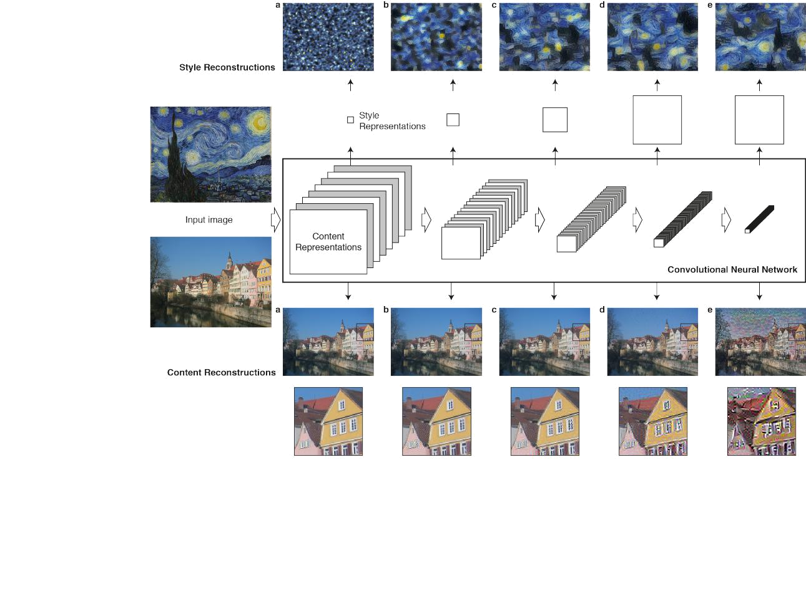

*fig 1 Convolutional Neural Networks,content and style representations*

7

**5. UML DIAGRAMS**

**5.1 USE CASE DIAGRAM**

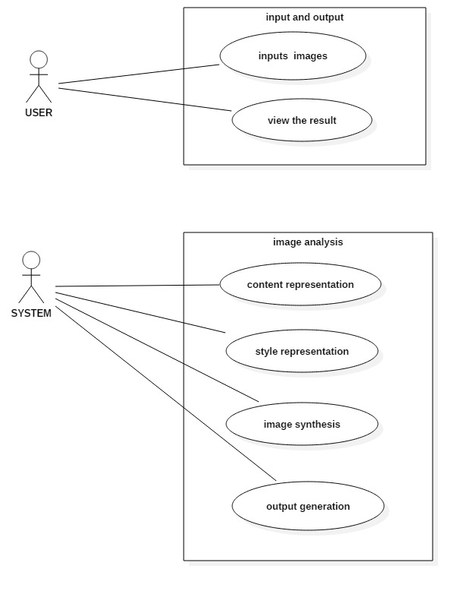

8

The actors in the system are the user and the system itself. The user gives a pair of input images for testing into the system. The system then processes the information and displays output to user. The system processes the input by performing some techniques of image analysis such as content representation, style representation, image synthesis and output generation.

Content representation requiresHigher layers in the network to capture the high-level content in terms of objects and their arrangement in the input image but do not constrain the exact pixel values of the reconstruction

Style representation includes the feature correlations of multiple layers, we obtain a stationary, multi-scale representation of the input image, which captures its texture information but not the global arrangement.

Image Synthesis and Output representation phases help in the reproduction of image formed on the basis of the algorithm applied in the neural network the image is then used to define output to user.

9

**5.2 ACTIVITY DIAGRAM**

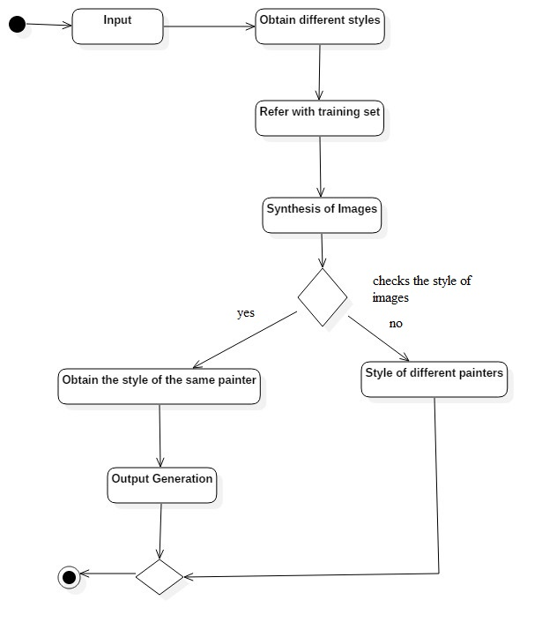

10

We start by accepting input data from which we obtain different styles on the basis of our classification of styles. This is then referred to the training set that was provided to derive an image synthesized by the various levels in the neural network. After synthesis we check if the style is same if so we say that the picture was painted by the same painter else it wasn’t. This is displayed as output to the user and program is brought to halt.

11

**5.3 SEQUENCE DIAGRAM**

system

user

Inputs data

Content representation

Style

representation

Image

synthesis

Output data

12

User inputs data to the system. Content represtentation is done by the system to visualize the information each layer contains about the input image by reconstructing the image only from the feature maps in that layer. After content representation, style representation is done to visualise the information captured by the style feature spaces built on different layers of the network by constructing an image that matches the style representation of a given input image. Then the image is synthesized by mixing the style and content to produce a new image. After synthesis we check if the style is same if so we say that the picture was painted by the same painter else the picture was painted by different painter. This is displayed as output to the user .

13

**6. DATA FLOW DIAGRAM**

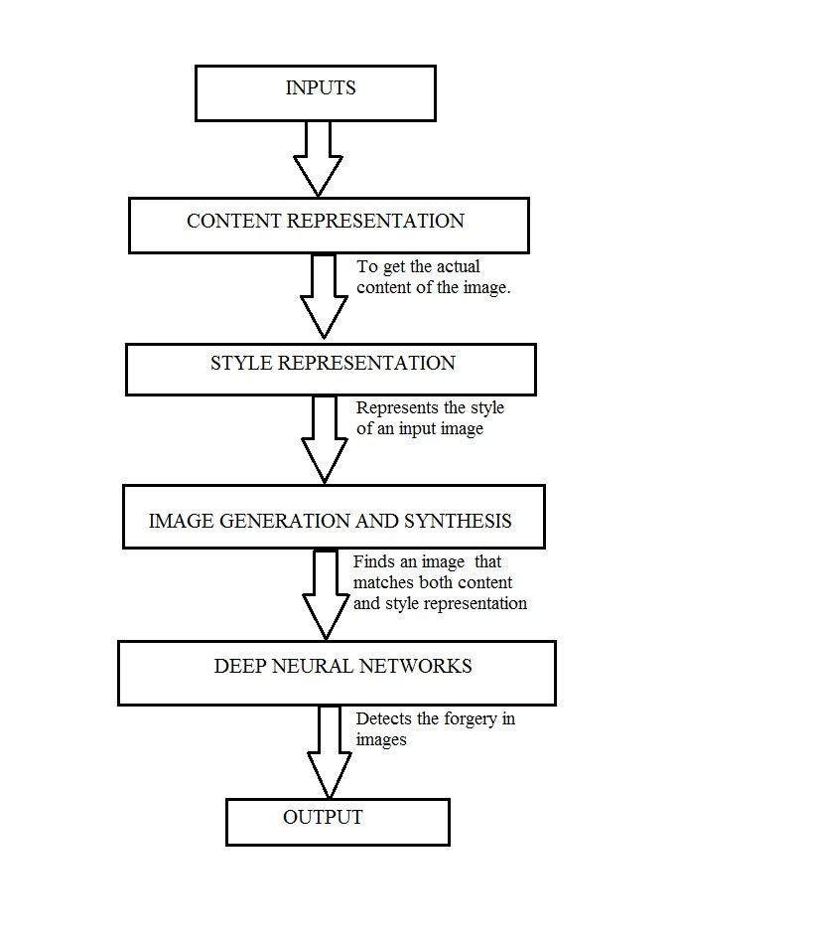

14

After accepting input data from the user, next is the content representation phase in which the actual content of the image is obtained. Next is the style representation phase in which the style of the input image is obtained. After these two phases is the image synthesis and generation phase in which it finds an image that matches both content and style representation. Next is the deep neural network phase which detects forgery in images. Last is the output phase which displays result to user.

15

**REFERENCES**

[1]. Gatys,Leon A., Alexander S.Ecker, and Matthias Bethge.”neural algorithm of artistic style.”arXiv preprint arXiv:1508.06576 (2015).

[2]. Quiroga,Rodrigo Quian,and Carlos Pedreira.”How do we see art:an eye-tracker study.”(2011).